Check Stock

Flow of Events

Use Case Name: Add Stock
Participating Actor: Stock Manager
Entry Conditions:
- The Stock Manager has logged in successfully and is displayed the Stock Manager menu.
- The Add Stock function has been invoked.

Flow of Events:

- The Stock Manager presses the ‘Add Stock button.
- The application opens a new window displaying the text boxes for the name of the component and the quantity display with a randomly generate number for the batch number.
- The Stock Manager can click on the text boxes and enter the correct data.
- The Stock Manager then clicks “Enter”.
Exit Conditions:
- The Stock Manager has clicked ‘Exit’ button.
- The ‘Add Stock’ window closes, and the user is displayed the Stock Manager menu screen.

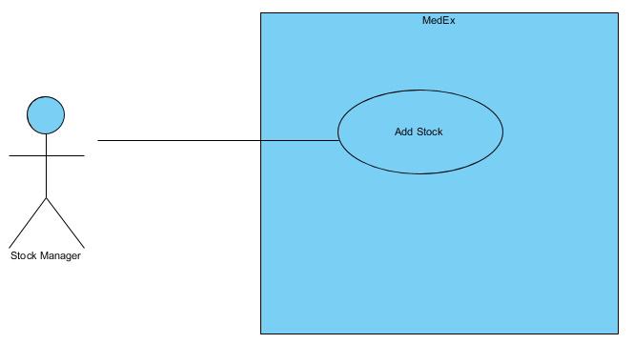
Use Case Diagram

